### **Technical Round 1 – Analytics Proposal**

| **Name of the Analytic** | **Description** |
| --- | --- |
| 1. Group Type Distribution | Count the occurrences of each group type (public, private, etc.) within the dataset to understand the distribution of group privacy settings. |
| 1. Average Member Count | Calculate the mean of the 'member_count' column to determine the average size of groups. |
| 1. Admin to Member Ratio | Divide the number of administrators by the number of members for each group to assess the management structure. |
| 1. Bot Presence Analysis | Calculate the proportion of bots to human members in each group to evaluate the level of automation. |
| 1. Pinned Message Frequency | Determines the recency of pinned messages by comparing 'pinned_messages_timestamp' with the current date. Helps analyze how frequently messages are pinned and whether they are recent or old. |
| 1. Group Visibility Trends | Count how many groups fall under each visibility category (public, restricted, etc.) to observe trends. |
| 1. Member Join Rate | Group members by their join date and calculate the average number of new members joining per day. |
| 1. Role Distribution | Tally the number of members with each role (admin, member, moderator) to understand group governance. |
| 1. Message Type Breakdown | Categorizes messages based on their type (e.g., text, media, links) and counts the frequency of each category. Helps analyze message composition, identify content trends, and understand user engagement patterns in groups. |
| 1. Media Sharing Insights | Tracks the frequency of media-sharing messages in each group. Helps analyze user engagement, identify trends in media usage, and understand the prevalence of shared media content over time. |
| 1. Hashtag Usage Analysis | Detect messages that include hashtags and evaluate the usage patterns of hashtags within the group. |
| 1. URL Sharing Patterns | Tracks the number of messages containing URLs in each group. Helps analyze external content sharing behavior, identify frequently shared links, and understand engagement trends with external resources. |
| 1. Message Interaction Metrics | Tracks the total number of replies, views, and forwards for each message. Helps measure engagement levels, identify highly interactive messages, and analyze user interaction trends within groups. |
| 1. Active User Identification | Tracks the number of messages sent by each user to identify the most active participants. Helps analyze user engagement, recognize key contributors, and understand participation trends within the group. |
| 1. Group Engagement Score | Calculates a composite score by combining and weighing different interaction metrics (replies, views, forwards) for messages within each group. Helps assess overall group engagement, identify periods of high or low activity, and measure the effectiveness of group interactions. |
| 1. Message Sent by Admins | Measures the number of messages sent by group admins within a given time period. This helps understand the level of admin engagement and their role in moderating or managing the group. If admins are less active in communication, it might indicate issues with management or a need for intervention. |
| 1. Member Lifespan | Calculates the time span from the join date to the current date for each member. Helps determine the average membership duration, track member retention, and analyze group activity over time. |
| 1. Cross-Group Activity | Identifies users who are members of multiple groups and counts how many groups they are active in. Helps analyze user participation across different groups, identify highly engaged members, and track activity patterns across multiple communities. |
| 1. Peak Activity Times | Extracts the hour from each message's timestamp and identifies the hour with the highest message frequency. Helps analyze when users are most active, track peak engagement periods, and understand activity patterns throughout the day. |
| 1. Message Impact Score | Calculates an impact score for each message by combining and weighting the number of views, replies, and forwards it has received. Helps measure the effectiveness and reach of individual messages, identify high-impact content, and analyze engagement levels within the group. |

**Entity-Relationship Diagram (ERD)**

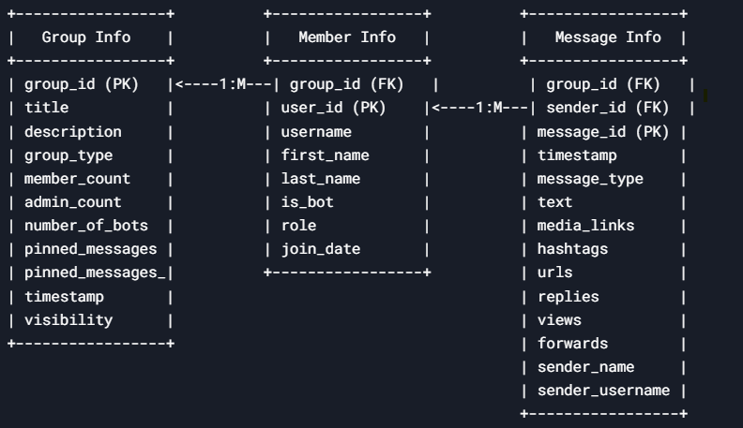

**Key Points:**

* Primary Keys:
  + group_id in Group Info.
  + user_id in Member Info.
  + message_id in Message Info.
* Foreign Keys:
  + group_id in Member Info and Message Info links to Group Info.
  + sender_id in Message Info links to Member Info.
* Constraints:
  + REQUIRED fields must have values.
  + NULLABLE fields can be empty.
* Data Types:
  + STRING, INTEGER, BOOLEAN, TIMESTAMP, and JSON are used as per the schema.